MANDOTHI VILLAGE
COMPREHENSIVE VILLAGE ANALYSIS & ROADMAP REPORT
Bahadurgarh Tehsil | Jhajjar District | Haryana, India | PIN: 124506

SECTION 1: ROADMAP / ROUGH SKETCH OF MANDOTHI VILLAGE
The schematic map below illustrates Mandothi village — its internal roads, key landmarks, agricultural areas, canals, approach roads, and boundary. This is a rough sketch for reference based on census, geographic, and community data.
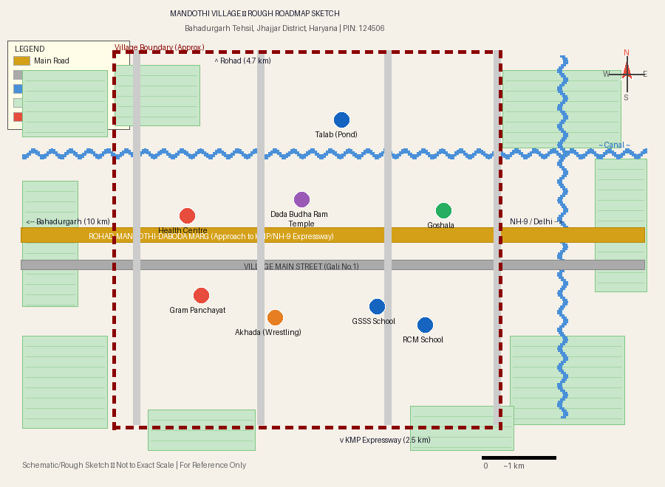
* Schematic map -- not drawn to exact scale. Based on Census 2011 data, geographic records, and community sources.

SECTION 2: VILLAGE OVERVIEW & BASIC FACTS
Parameter | Details
Village Name | Mandothi (Mandethi)
Tehsil | Bahadurgarh
District | Jhajjar
State | Haryana, India
Division | Rohtak
PIN Code | 124506
Census Code | 061765
Total Geographical Area | 2,562 Hectares (25.62 sq. km)
Altitude / Elevation | 220 metres above sea level
Languages | Hindi & Punjabi
STD / Telephone Code | 0180
Gram Panchayat | Yes -- own Gram Panchayat (since 2009)
Distance from Bahadurgarh | 10 km (sub-district HQ)
Distance from Jhajjar | 25 km (district HQ)
Distance from New Delhi | ~40 km (northwest)
Distance from Delhi-Haryana border | ~12 km east

SECTION 3: DEMOGRAPHIC & POPULATION DATA
Per the 2011 Census, Mandothi had a recorded population of 10,612. Community sources estimate the current population at approximately 35,000+ given significant growth since the census.

Demographic Indicator | Figure
Total Population (Census 2011) | 10,612
Estimated Current Population | ~35,000+
Male Population | 5,824
Female Population | 4,788
Sex Ratio | 822 females per 1,000 males
Total Households | 1,985
Children (Age 0-6 years) | 1,264 (11.91% of population)
Child Sex Ratio | 785 girls per 1,000 boys
Scheduled Caste (SC) Population | 1,702 (16.04%)
Scheduled Tribe (ST) | None
Total Workers | 3,699
Main Workers (more than 6 months) | 71.42%
Marginal Workers (less than 6 months) | 28.58%
Cultivators | 1,154
Agricultural Labourers | 165

SECTION 4: LITERACY & EDUCATION
Literacy Indicator | Mandothi | Haryana State Avg.
Overall Literacy Rate | 78.06% | 75.55%
Male Literacy Rate | 86.08% | --
Female Literacy Rate | 68.36% | --

Mandothi exceeds the Haryana state literacy average. The village is served by 9 schools:
- GSSS Mandothi -- Government Senior Secondary School
- GGSSS Mandothi -- Government Girls Senior Secondary School
- GGPS Mandothi-1 & GGPS Mandothi-2 -- Government Girls Primary Schools
- GPS Mandothi-1 & GPS Bari -- Government Primary Schools
- RCM Modern High School Mandothi (Private)
- Ravi Sr. Secondary School Mandothi (Private)
- Silothi Govt. Middle School (nearby)

SECTION 5: GEOGRAPHY & CONNECTIVITY

Physical Geography
Mandothi lies on flat, fertile Gangetic-influenced plains of northwestern Haryana at 220 m elevation. Surrounded by canal networks, the village enjoys reliable irrigation. The climate is semi-arid -- hot summers, cool winters, moderate monsoon.

Road Connectivity
Route / Road | Distance
National Highway NH-9 (Delhi-Rohtak Corridor) | 3.5 km from village
NH-248A | Reachable via approach roads
KMP Expressway (Kundli-Manesar-Palwal, 135 km 6-lane) | 2.5 km via Rohad-Mandothi-Daboda Marg
Bahadurgarh (nearest town & economic hub) | 10-13 km
Jhajjar (District HQ) | 25 km
Rohtak | 38 km
Gurgaon | 37 km
Delhi NCT | ~45 km

Railway Connectivity
Railway Station | Distance
Asaudah Railway Station | 5.7 km
Rohed Nagar Halt (nearest) | 6.7 km
Sampla Railway Station | 10 km
Bahadurgarh Railway Station | 12 km

Metro & Air Connectivity
- Delhi Metro Green Line (Brigadier Hoshiar Singh station): ~11.8 km from Mandothi
- Indira Gandhi International Airport, New Delhi: 36-41 km

SECTION 6: ECONOMY & LIVELIHOODS

Agriculture
Agriculture is the mainstay of the local economy, supported by canal irrigation. Key crops: wheat, rice (kharif/rabi rotation), and sugarcane for diversification. Jaggery is produced locally. Over 1,154 cultivators manage the 2,562-hectare village land.

Industrial Employment
Bahadurgarh -- one of Haryana major industrial hubs -- provides significant off-farm employment including footwear manufacturing for brands like Puma, Adidas, and Aqualite. The KMP and NH-9 corridor connects villagers to Manesar and Gurugram industrial belts. Most working-age residents find employment locally.

Development Needs
The village aspires to larger-scale industrial investment. Key priorities: access to institutional credit, improved healthcare, road upgrades, and continued education development. Active government schemes: NREGA, Indira Awas Yojana, NRLM, and SLWM (Solid and Liquid Waste Management).

SECTION 7: GOVERNANCE & POLITICAL REPRESENTATION
Level | Details
Village Governance | Gram Panchayat with elected Sarpanch
Notable Sarpanch (post-2016) | Pehelwan Satpal (Satpal Chitti) -- Head of All Haryana Sarpanch Association
Late Former Sarpanch/MLA | Late Ch. Uday Singh Dalal (passed away 13 February 2020)
Assembly Constituency | Beri Assembly Constituency
Assembly MLA | Dr. Raghuvir Singh Kadian
Lok Sabha Constituency | Rohtak Parliamentary Constituency
Parliament MP | Arvind Kumar Sharma
Block Panchayat | Bahadurgarh Block Panchayat
Nearest Police Station | Bahadurgarh Tahsil Police Station

SECTION 8: CULTURE, SPORTS & HERITAGE

Wrestling -- The Soul of Mandothi
Mandothi is celebrated as the "Village of Wrestlers." Pehelwani is a way of life -- nearly every household has a wrestler. The village maintains a traditional Akhada (wrestling ground) and equally supports girls in sports. Notable wrestlers include:
- Darmender Dalal & Sonu Dalal -- prominent competitive wrestlers
- Chota Sonu Pehelwan, Kala Pehelwan, Karan Singh Pehelwan
- Nihala Pahlwan, Prithi Pehelwan, Ratankawar Pehelwan, Surender Pehelwan (Dhandha)
- Subedar Neki Ram -- WWII era celebrated wrestler-soldier

Military Heritage
The village has a distinguished tradition of military service and gallantry:
- Subedar Khazan Singh Dalal -- gallantry in 1965 Indo-Pak War, 3 Jat Regiment, retired as Honorary Captain
- Kanwal Singh -- served in the Indian National Army (INA)
- Capt. Manphool Singh -- veteran of both World Wars

Dominant Clan & Community
The primary gotra (clan) is Dalal -- a branch of Mann and Sihag gotras. Mandothi is one of the largest Dalal communities in Haryana. Multiple castes and communities coexist harmoniously. Social ties are extremely strong.

Religious & Cultural Sites
- Dada Sita Ram Temple -- important village shrine
- Dada Budha Ram Temple -- major local religious site
- Goshala (Cow Shelter) -- large facility with free treatment for sick cattle; annual Haryanvi cattle ragni competition held 11-14 January every year

Historical Notes
- Mandothi had a British-era airstrip, reflecting its historical strategic importance
- The 1994 Panchayat elections brought national attention due to violence that claimed four lives

SECTION 9: INFRASTRUCTURE & FACILITIES
Facility | Status / Details
Schools | 9 schools (government + private, co-educational and single-sex)
Primary Health Centre | Available within the village
Nearest Medical College (PGIMS) | Rohtak (~38 km)
Electricity | Fully electrified
Drinking Water | Running water supply available
Road Network | Internal roads + approach to NH-9 and KMP Expressway
Goshala | Large functional cow shelter with free veterinary services
Post Office | Mandothi Post Office (PIN 124506)
Banking / Finance | Limited -- identified as a key development priority
Telecom | Available (STD Code: 0180)

SECTION 10: NEARBY ATTRACTIONS & TOURISM
Attraction | Distance from Mandothi
Bhindawas Bird Sanctuary & Ramsar Wetlands | 36-41 km
Gurukul Jhajjar Museum (largest museum in Haryana) | ~25 km
Mata Bhimeshwari Devi Mandir, Beri | 25 km
Bua Wala Talab, Jhajjar | 23 km
Gurgaon | 37 km
Delhi NCT | ~45 km
Noida | ~57 km
Pratapgarh Farms (agri-tourism) | 30 km
Rattangarh Farms | 38 km

Sources: Census of India 2011 | villageinfo.in | bharatpedia.org | jatland.com | localfeedback.org | onefivenine.com | haryana21.com | Compiled March 2026

